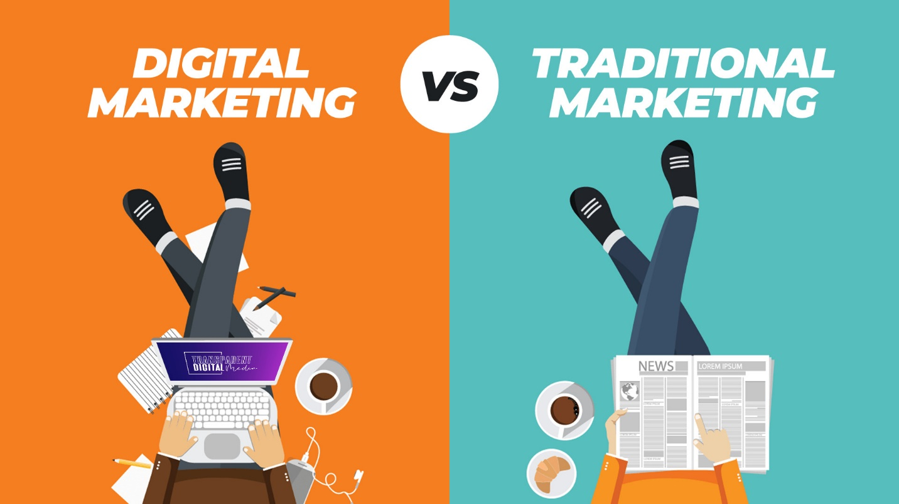

Traditionally, marketing meant reaching a broad audience through television commercials, billboards, or print ads. This approach often resembled a one-way street - companies delivered messages, hoping they'd resonate with potential customers. Social media marketing, on the other hand, thrives on interaction. Brands can connect directly with their audience, fostering a sense of community. Social media platforms allow for targeted advertising, reaching specific demographics or people with particular interests. This focus on personalization can lead to a higher return on investment compared to traditional methods.

Engagement is a key difference between the two approaches. Traditional marketing is passive - you see an ad, hear a jingle, and move on. Social media marketing allows for two-way communication. Companies can respond to comments and messages, answer questions, and address concerns in real-time. This builds stronger relationships with customers and fosters brand loyalty. Additionally, social media provides valuable insights into customer sentiment and preferences. Companies can use this data to refine their marketing strategies and ensure their messaging aligns with what their audience truly wants.

While social media offers distinct advantages, traditional marketing isn't dead. Billboards in high-traffic areas can still grab attention, and magazines can target specific demographics. The best approach often involves a strategic blend of both methods. Leveraging the strengths of traditional marketing for brand awareness and social media for engagement can create a powerful marketing force.